**IT TME**

Functional Design Document

May Release 2017: CHG107664  
Order Date to include Date and Time in OD

Ireland

# Document Approval

|  |  |  |  |
| --- | --- | --- | --- |
| **CHG Title** | Order Date to include Date and Time in OD | | |
| **Business Sponsor** | Andrew Slowey | **Function** | TME Ireland |
| **BTS Responsible** | Laura Sáez | **Function** | BTS TME |
| **ODC Responsible** | Miguel López | **Function** | ODC Data |
| **GTC Responsible** |  | **Function** |  |

This is to confirm that we have reviewed the functional specifications for the proposed solution. We agree with its contents and understand that the technical specifications will be designed based on this approved document.



# Revision History

|  |  |  |  |  |
| --- | --- | --- | --- | --- |
| Revision | Section(s) | Description | Editor | Date |
| 1.0 | - | Draft | Laura Sáez | 22/12/2016 |
| 2.0 | 2.6 | Change included in the last version of interface and time zone to be used | Laura Sáez | 02/01/2017 |
| 3.0 | 2.6 | Time zone to be GMT as suggested by Data team | Laura Sáez | 24/01/2017 |
|  |  |  |  |  |
|  |  |  |  |  |
|  |  |  |  |  |
|  |  |  |  |  |

# Business Process Overview

Ireland market request to update the type of Order Date field in OD Interface to include Date and Time of each order placed on their Web Tool

# 1.1 Impact Matrix

|  |  |
| --- | --- |
| **GRM Functionality** | Orders |
| **Impact Current Functionality?** | No |
| **Markets Affected** | Ireland, France, Kazakhstan, Switzerland |
| **Applications Affected** | Data |
| **Risk of Implementing the change** | None |

# Description of the Functional Change

## 

* 1. Changes in Siebel Sales

None required.

* 1. English Captions  
     (Translations should be provided for non-English Markets)

None required.

* 1. *Changes in the ETL*

None required.

* + 1. *Initial Loads/Massive Data updates*

None required.

* + 1. *Performance test/Indexes creation*

None required.

* 1. *Changes in OBIEE*

None required.

* 1. *Data Dictionary*

None required.

* 1. *Changes in Data Interfaces*
     1. *Inbound*

Field “ORD_ORDER_DT” of OD (Orders) interface should be updated to allow Date and Time format instead of only Date as currently happens.

At this moment the time is defaulted to 12:00:00 AM so this behavior should be maintained for those markets that do not inform time in that field.

The time zone to be used in the data load of this field should be GMT. This means that markets that are out of this time zone should apply a transformation in their middleware before the data load.

This change should be applied to the last version of the interface, the previous versions should not be affected.

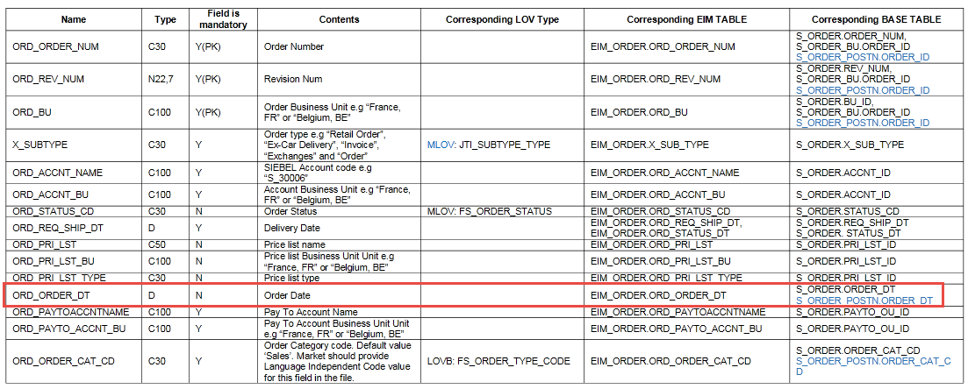

|  |  |  |  |  |  |
| --- | --- | --- | --- | --- | --- |
| **OLTP Orders - OD** | | | | | |
| **#** | **Entity** | **Field Name** | **Contents** | **Data type/format** | **Transformation** |
| 1 | Orders | ORD_ORDER_DT | Order Date | Date | *Format should be updated to allow* ***Date and Time*** *data in CET time zone.* |
|  |  |  |  |  |  |

* + 1. *Outbound*

None required.

* + 1. *Initial Loads*

None required.

* + 1. *Performance test/Indexes creation*

None required.

* 1. *Changes in Batch Processes / Aggregations / DRP*

None required.

* 1. *Use Case*

|  |  |  |
| --- | --- | --- |
| **Role**  *Trade Marketer, ASM, Local Admin…* | **Application**  *Sales, Analytics, ETL, Batch, Interface* | **Step**  *Description of the step and its expected output* |
| Local Admin (IT) | Interface | Generate new OD file, or use an existing one, to load some Orders information into Siebel Sales |
| Local Admin | Sales | After data load is completed check in Orders view that those orders loaded using OD interface have the Order Date field correctly filled with date and time information. |
|  |  |  |